**RAPID ENERGY ASSISTANCE PROGRAM AGREEMENT**

This Agreement (“Agreement”) entered into as of (*date*) is to facilitate and establish the terms by which the Vermont Department of Public Service (the “Department”) may provide a bulk payment of funds under the Rapid Energy Assistance Program (“REAP”) to (*TYPE NAME OF FUEL VENDOR HERE),* a utility provider who services customers within the State of Vermont (the “Provider”). The REAP funds are for the purpose of providing utility assistance to aid certain rental households (“Eligible Households”) who meet the REAP eligibility terms of the utility assistance program administered by the Department. REAP is an enhancement to the VERAP-U (“Vermont Emergency Rental Assistance Program for Utilities”) to support bulk fuel customers.

This Transfer Agreement consists of nine pages including the following attachments:

Attachment A: Program Requirements

Attachment B: Provider Participation Details

Attachment C: Draw Request Form

Attachment D: Monthly Report

Attachment E: True Up of the Cash Advance

TERMS OF REAP

1.This payment and transfer of REAP is based on reasonable estimates of arrears and prospective payments owed or due by multiple households, before their application and documentation requirements are satisfied. This allowance is made to speed the delivery of assistance.

2. The amount of funds shall be based on a reasonable estimate by the Provider of the need by Eligible Households; both parties must agree to the appropriateness of the estimate. The amount of the estimate will be facilitated by completion of the Draw Request and Calculation Worksheet, the form of which is attached hereto as Attachment B. The Provider may make subsequent requests for funds by demonstrating that the drawn down funds have been significantly depleted and customer need remains outstanding.

3. Payments shall be made by the Department to the Provider through the State of Vermont. If a Provider does not have an active account with the State of Vermont, the Provider will be required to provide a W9. If direct deposits are desired, please request a State- provided ACH form. Please send email request for forms to: psd.utilityassistance@vermont.gov.

4. Payments to Eligible Households from REAP must be used to satisfy 1) any utility arrears owed to the Provider and accrued after March 13, 2020, and 2) up to three (3) months of prospective utility payments that will be credited to the Eligible Household’s account with the Provider. No more than EIGHTEEN (18) months of benefits may be provided in total for arrears or prospective payments. Prospective payments may not be applied to more than three (3) months, with the total months of arrears and prospective payments not totaling more than EIGHTEEN (18) months of usage.

5. Payments may be made to any fuel customers who are part of Eligible Households for any amount of arrears. Budget customers are eligible for three months of prospective funds based upon the budget consumption data and daily price at application date or date of calculation (whichever is higher). Customers may recertify every three months and continue to draw benefits until they have reached eighteen months.

6. The Provider must file reports of all payments to Eligible Households made from the REAP funds. Monthly reports should be submitted by the 5th business day of the month.

ELIGIBLE HOUSEHOLDS

7. An Eligible Household must meet all of the following criteria, consistent with the eligibility requirements of VERAP:

A. The household is obligated to pay rent on a residential dwelling in Vermont or owns a manufactured home and pays rent on the parcel of land the manufactured home occupies,

B. The household has a household income at or below 80 percent of the county’s area median income (“AMI”),

C. One or more individuals within the household has qualified for unemployment benefits or experienced a reduction in household income, incurred significant costs, or experienced other financial hardship due, directly, or indirectly, to the COVID-19 outbreak (this may be evidenced by self-attestation alone), and

D. One or more individuals within the household can demonstrate a risk of experiencing homelessness or housing instability, which may be evidenced by self-attestation alone.

CONFIDENTIALITY, RECORDKEEPING

8. The use of REAP funds and transfer of any data should comply with applicable privacy requirements, including any data sharing agreement already in force between the parties.

9. The payment out of the REAP benefits to customers must include appropriate safeguards and processes to ensure payments are made only for Eligible Households.

10. The Provider must support the Department and its VERAP-U partners in obtaining information necessary for its reporting requirements to the U.S. Treasury.

11. The Provider agrees to maintain its records for three years from the date of the “true up” report.

12. The Provider agrees to spot reviews and to comply with any audit by providing back up documentation such as a copy of a delivery ticket for a customer.

13. The Provider agrees to comply with the provisions of the U.S. Treasury which require company specific information and/or registration with SAMS (“System for Award Management,” i.e., Simplified SAM Registration Services for Federal Contracting and Nonprofit Grants).

COORDINATION BETWEEN REAP AND VERAP-U

14. The ReFrame VERAP program administered by the Vermont State Housing Authority and the Department continues to process applications for rental and utility assistance.

15. REAP approved applicants that have indicated they are customers of the Provider will be made available to the Providers.

REQUESTING ADDITIONAL REAP, RETURNING UNSPENT REAP AND RECONCILING PAYMENTS

16. If the Provider has exhausted the REAP funds provided to it, the Provider may request additional REAP funds from the Department at any time based upon reasonable customer need. The Provider may request additional REAP funds from the Department at any time, and the Department shall provide such funds so long as funds remain available, and the Provider remains in good standing subject to the terms of this Agreement.

17. The Provider shall provide a True Up Cash Advance report every 90 days by the 5th of the month following the end of the quarter to the Department.

18. Providers may continue to participate in the REAP to benefits its customers until notified that the Program has ended per communication from the Department, or the Provider states its intention to terminate its participation and returns any unspent funds.

PROVIDER

By:

Date:

VERMONT DEPARTMENT OF PUBLIC SERVICE

By:

Date:

June E. Tierney, Commissioner

Attachment A: Program Requirements



Attachment B: Draw Request and Calculation Worksheet

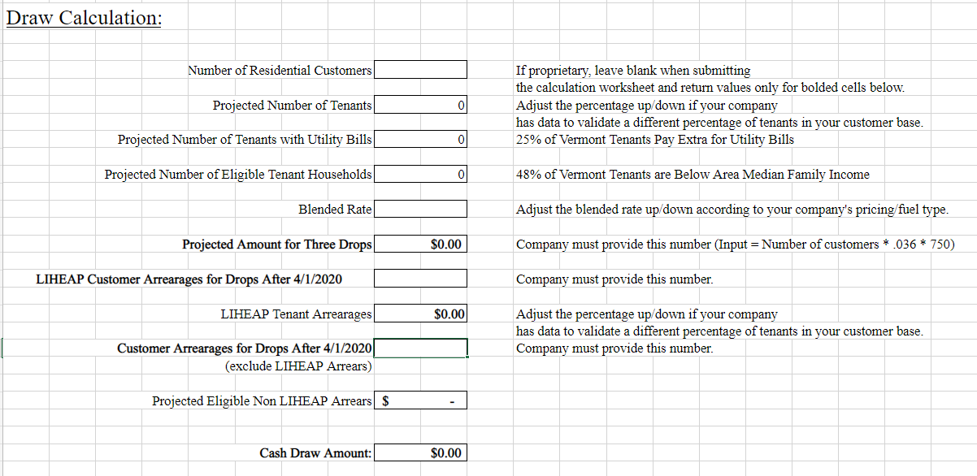

Attachment C: Provider Participation Details

*For any payee, that is not a person or household, the State must collect either the SAMs registration # OR complete the executive compensation details in the form below.*



Attachment D: Monthly Report

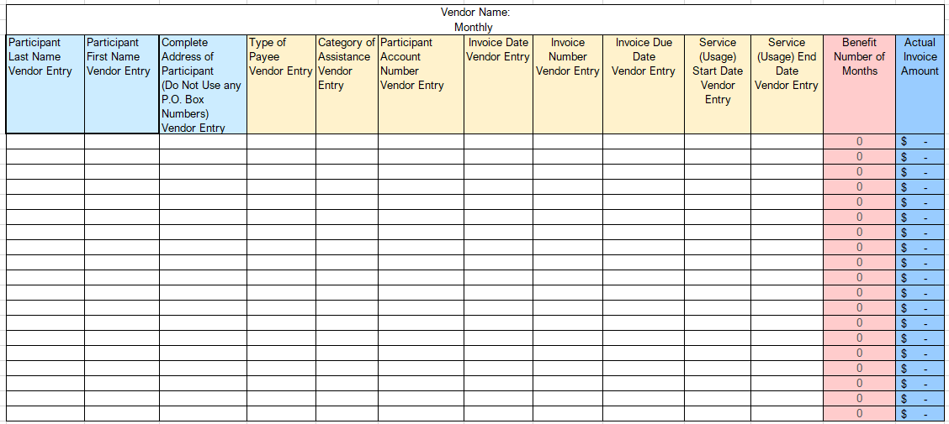

Attachment E: Cash Advance True Up Report Template

